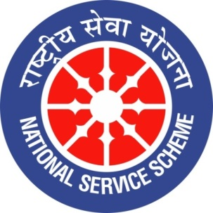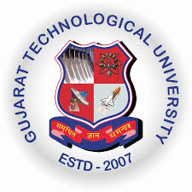
GUJARAT TECHNOLOGY UNIVERSITY
NATIONAL SERVICE SCHEME
Government Poly-Technic for Girls, Ahmedabad
A Report on “Aazadi ka Amrut Mahotsav” from 12th Mar-2021 to 5th Apr-2021 of GPG, Ahmedabad

NSS Unit Name/College Name: GPG, Ahmedabad (614)
Event NAME: Aazadi ka Amrut Mahotsav
Event Date, Time and Location: 12/03/2021 to 05/04/2021 online
Brief Description of the Event:
Our Institute Government Polytechnic for Girls, Ahmedabad has organized many events as a celebration of “Aazadi ka Amrut Mahotsav”. Numbers of events were performed in which many students of our institute has participated. The events organized are webinar on “ Ek Bharat Shreshth Bharat”, Essay competition on "Woman freedom fighters of India", Quiz Competition on "Woman Freedom Fighters", Movie screening on patriotic theme (Short film) and Rangoli Competition on "Aazadi". Details of the events like the date of the event, activity performed and number of students participated are given in the table below. Winners of all the events are going to be awarded by institute certificates. Certificates would be provided once students are allowed to come to the college.

Sr. No. | Date | Event Name | No. Of students participated
1 | 12/03/2021 | Webinar on "Ek bharat shreshth bharat" by Dr. Hari Desai (PhD), Director at Chimanbhai Patel Institute journalism and communication(CPIJC) running by BJMC programme affiliated to Gujarat university | 100
2 | 16/03/2021 | Cycle rally 9:00 AM at GGP, Campus. | Due to current COVID situation this event is not conducted.
3 | 17/03/2021 | Essay competition on "Woman freedom fighters of India". | 20
4 | 22/03/2021 | Quiz Competition on "Woman Freedom Fighters" OR " Dandi March" | 111
5 | 26/03/2021 | Movie screening on patriotic theme (Short film) | 31
6 | 03/04/2021 | Rangoli Competition on "Aazadi" | 18

Major Outcomes of Event:
- Students gained more information about woman freedom fighters of India.
- Students gained more knowledge about “Dandi Marsh”.
- Students became more aware about the struggle of freedom fighters of India which added more values to them.

Photographs of the Event:
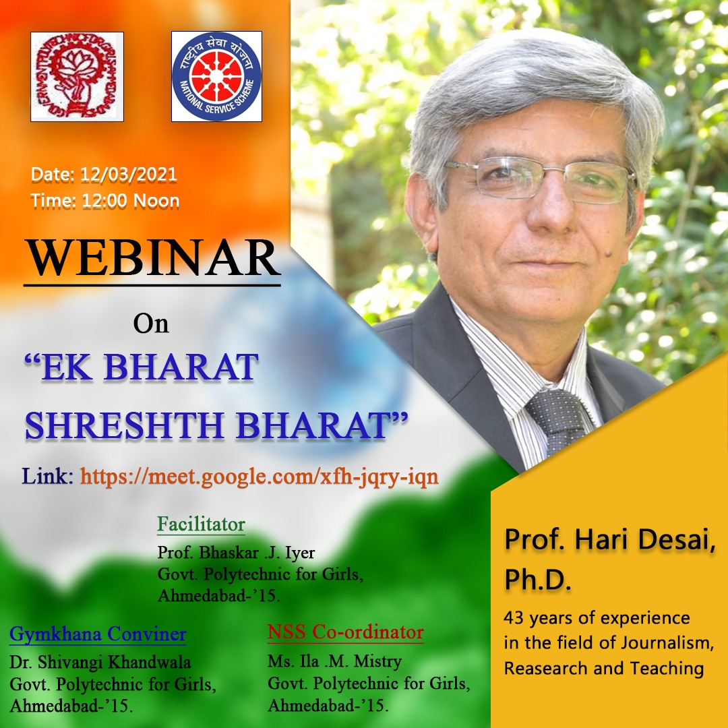
Poster of Webinar on “ Ek bharat shreshth bharat”
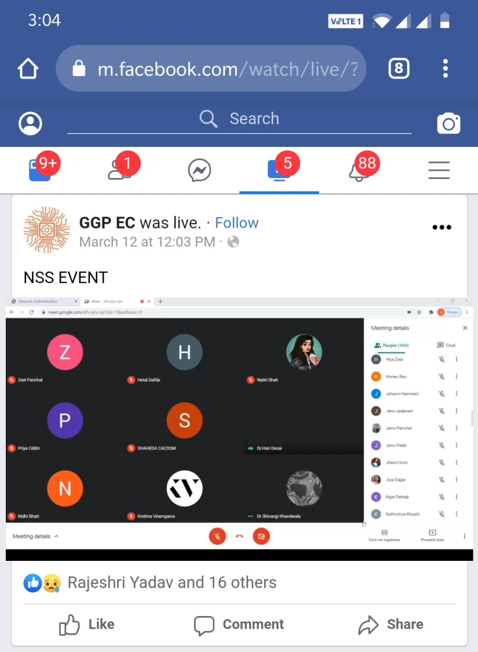
Screenshot of facebook live page of webinar on “Ek bharat shreshth bharat”
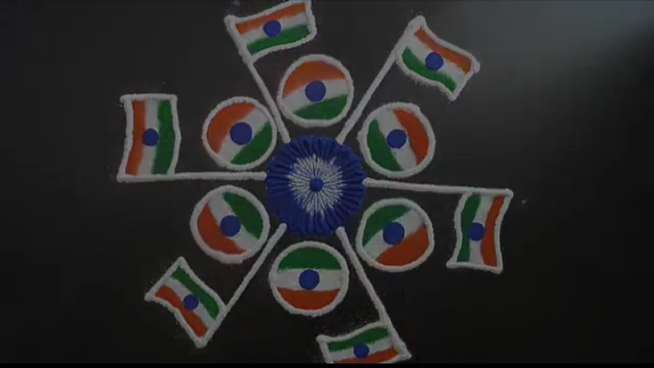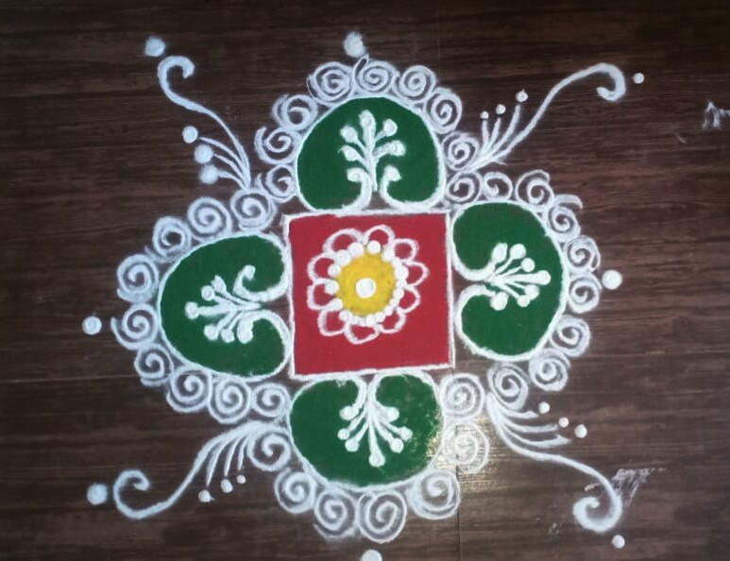
Rangoli made by students
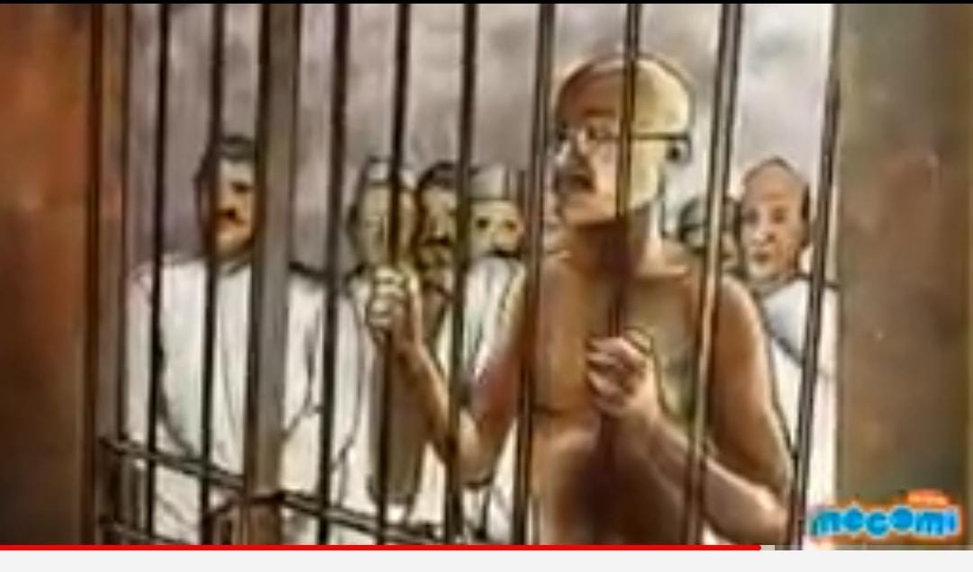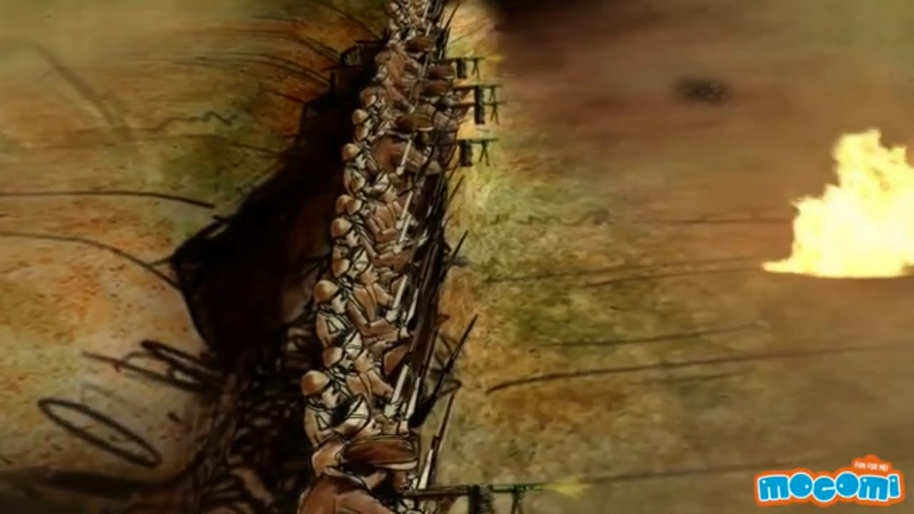
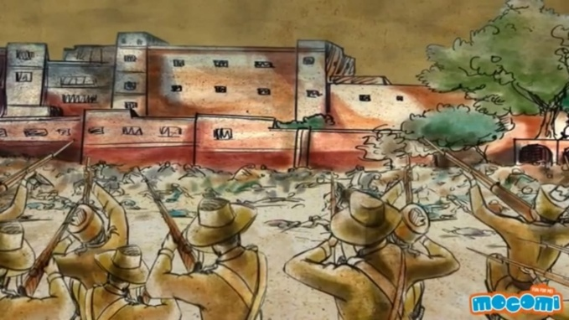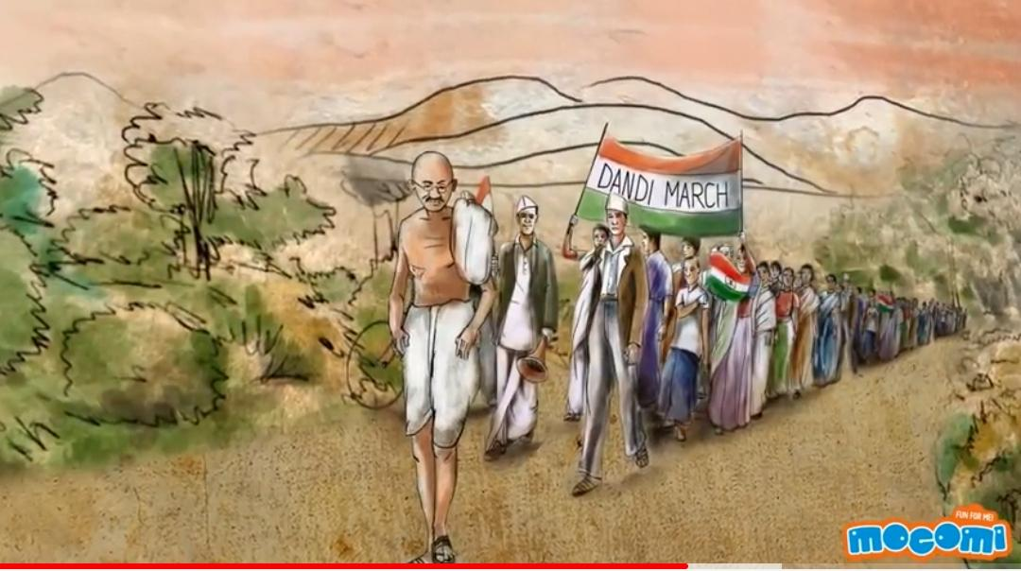
Screenshot of movie screeming

Names of Coordinators :-
- Smt Shivangi M. Khandwala (Lect in CA-CDDM)
- Miss Ila M. Mistry (Lect in EC)

